3.12

First of all keep in mind that when CDF is given to you, the P(x<2)=F(2) and P(x>2)=1- F(2)

It means that CDF will give you the total probability till x<2.

So if you need to find the probability with the help of CDF you just need to find the probability at the point in CDF.

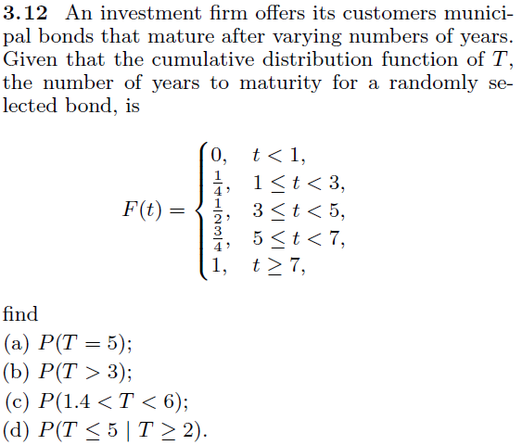

1. P(T=5) = F(5) - F(4)= $\frac{3}{4}-\frac{1}{2}$

As you can see the CDF where ½ is the probability of 3≤t<5 it means that F(4) is also ½

1. Already explained that P(T>3)=1 - F(3) = 1 – ½
2. F(6) – F(1.4) = ¾ - ¼

1.4 is >1 but <3 so F(1.4)= ¼ and same goes with F(6)

(d) In this part you have to find the conditional probability

We know that P(A|B)=P(AႶB)/P(B)

So in this case you have to find P(T≤5|T≥2)

You have to find T≤5 and T≥2 so the common probability is 2≤T≤5

So $P(T≤5|T≥2)=\frac{ P(2≤T≤5)}{P(T≥2)}$

Now to find the common probability between 2 and 5 P(3≤T≤5)-P(1≤T≤3)=P(2≤T≤5)

And P(1≤t<3) = ¼ so P(t<2)=1/4

So P(T>2)=1-1/4